Sorts—A Review
Bubble Sort
- short description of algorithm: compares side-by-side. Takes 2 nested loops.
- best case: O( n² ) when the data is in order.
- worst case or guaranteed performance: O( n² ) when the data is in reverse order.

Selection Sort
- algorithm: _____________________________________________________
- best case: O( ) when the data is ____________________
- worst case or guaranteed performance: O( ) when the data is ____________________

Insertion Sort
- algorithm: ____________________________________________________
- best case: O( ) when the data is ___________________
- worst case or guaranteed performance: O( ) when the data is ___________________

Merge Sort
- algorithm: ____________________________________________________
- average case or expected performance: O( ) when the data is ___________________
- worst case or guaranteed performance: O( ) when the data is ___________________

Quick Sort
- algorithm: ____________________________________________________
- average case or expected performance: O( ) when the data uses ______________
- worst case or guaranteed performance: O( ) when the data uses _______________

Heap Sort
- algorithm: ___________________________________________________
- average case or expected performance: O( ) when the data is __________________
- worst case or guaranteed performance: O( ) when the data is __________________

Here are some sorting websites: http://sorting.at/
https://www.cs.usfca.edu/~galles/visualization/ComparisonSort.html
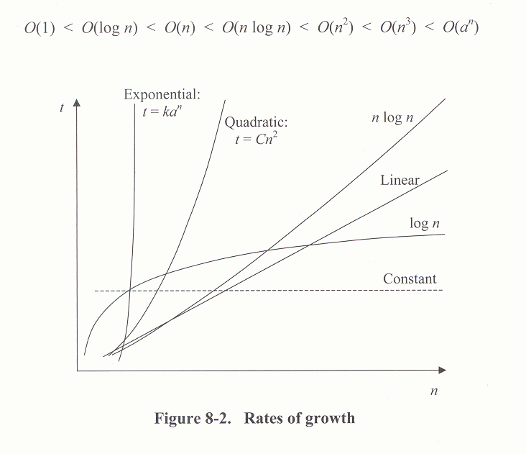Wikipedia entries

